

ZEN CARBON PRODUCT CATALOGUE

Product Code
ZEN-[Category Code]-[Thickness(mm)]-[Length(mm)]-[Width(mm)]-[Strength Class]-[Finish/Color Code]
Category | Code | Example
Paving Block | PB | ZEN-PB-60-200-100-C35-GRY
Hollow Block | HB | ZEN-HB-200-400-200-C7.5-GRY
Solid Block | SB | ZEN-SB-150-400-200-C10-GRY
Hollow Pot Block | HP | ZEN-HP-230-380-200-C10-GRY

PAVING BLOCKS
SKU | Product Type | Dimensions (mm) | Thickness (mm) | Strength (N/mm²) | Color / Finish | Typical Use | Price (KES/m²) | Notes
ZEN-PB-50-200-100-C25-GRY | Quad Paver | 200×100 | 50 | 25 | Grey | Pedestrian walkways, light duty | 1150/m² | Medium Duty
ZEN-PB-60-200-100-C35-GRY | Quad Paver | 200×100 | 60 | 35 | Grey | Driveways, domestic parking | 950–1,100/m² | Most popular paver size
ZEN-PB-80-200-100-C49-GRY | Quad Paver Heavy Duty | 200×100 | 80 | 49 | Grey | Industrial/road pavements | 1,150–1,350/m² | Heavy duty
ZEN-PB-60-200-165-C35-RED | Behaton / Uni Paver | 200×165 | 60 | 35 | Red | Decorative driveways | 1,100–1,250/m² | Interlocking, aesthetic
ZEN-PB-80-200-165-C49-GRY | Behaton Heavy | 200×165 | 80 | 49 | Grey | Heavy duty / parking | 1,300–1,450/m² | Common for malls
ZEN-PB-60-205-195-C35-BLK | Hexagon Paver | 205×195 | 60 | 35 | Black | Decorative areas, plazas | 1,200–1,400/m² | Elegant finish
ZEN-PB-60-100-100-C35-NAT | 77 Square Paver | 100×100 | 60 | 35 | Natural | Garden / pedestrian | 1,000–1,200/m² | Compact grid pattern
ZEN-PB-60-330-110-C49-GRY | Pavia Paver | 330×110 | 60 | 49 | Grey | High-end pavements | 1,300–1,500/m² | Premium grade
ZEN-PB-60-PIAZZA-SET-C49-MIX | Piazza Set (Mixed Sizes) | 250–500×150–300 | 60 | 49 | Mixed | High-end commercial | 1,500–1,800/m² | For upscale designs
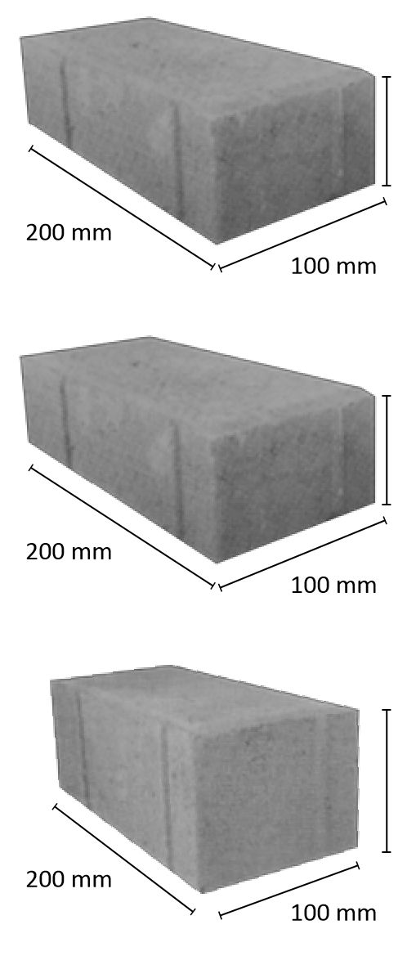
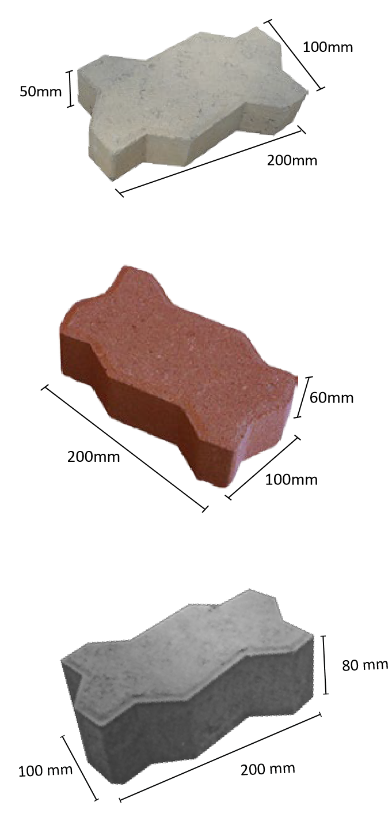
Quad paver blocks Interlock paving block

MASONRY BLOCKS — HOLLOW & SOLID
SKU | Product | Dimensions (mm) | Thickness (mm) | Strength (MPa) | Weight (kg) | Use | Price (KES/block) | Price (KES/m²)*
ZEN-HB-100-400-200-C7.5-GRY | Hollow Block 4" | 390×90×190 | 90 | 7.5 | 12 | Partition walls | 55–65 | 1,700–1,900
ZEN-HB-150-400-200-C10-GRY | Hollow Block 6" | 390×140×190 | 140 | 10 | 15 | External walls (light duty) | 65–75 | 1,850–2,100
ZEN-HB-200-400-200-C15-GRY | Hollow Block 9" | 390×190×190 | 190 | 15 | 18 | Load-bearing walls | 75–90 | 2,000–2,400
ZEN-SB-100-400-200-C10-GRY | Solid Block 4" | 390×90×190 | 190 | 10 | 14 | Internal partition | 60–70 | 1,850–2,000
ZEN-SB-150-400-200-C15-GRY | Solid Block 6" | 390×140×190 | 140 | 15 | 18 | External wall | 70–85 | 2,100–2,400
ZEN-SB-200-400-200-C20-GRY | Solid Block 9" | 390×190×190 | 190 | 20 | 24 | Load-bearing wall | 85–100 | 2,400–2,800
*Approximate 25 blocks/m² for 4", 20/m² for 6", 15/m² for 9" walling (with mortar).

HOLLOW POT BLOCKS (RIBBED SLAB INFILL)
SKU | Product | Dimensions (mm) | Weight (kg) | Strength (MPa) | Typical Use | Price (KES/block)
ZEN-HP-200-380-200-C10-GRY | Hollow Pot Block (Standard) | 380×200×200 | 8 | 10 | Light slabs | 85–95
ZEN-HP-230-380-200-C10-GRY | Hollow Pot Block (Medium) | 380×200×230 | 9 | 10 | Medium spans | 95–105
ZEN-HP-300-380-200-C10-GRY | Hollow Pot Block (Heavy) | 380×200×300 | 11 | 10 | Long-span floors | 110–130

COLOR / FINISH ADDERS
Finish | Code | Add-on (%) | Typical Application
Red oxide | RED | +10% | Driveways, estates
Black / Charcoal | BLK | +12% | Luxury pavements
Yellow / Sand | YLW | +8% | Garden paths
Natural Grey | GRY | Base price | Default

STRENGTH CLASS / QUALITY CONTROL
Code | Strength | Application | Lab Test Frequency
C25 | 25 N/mm² | Walkways | 1 batch / 3 days
C35 | 35 N/mm² | Driveways | 1 batch / 2 days
C50 | 49 N/mm² | Roads / Industrial | Every production day
C7.5 | 7.5 MPa | Non-load walls | Every 500 pcs
C10 | 10 MPa | General walls | Every 500 pcs
C15 | 15 MPa | Load-bearing | Daily QC sample

